Patricia Murthy
9802 – Pre-Final
Dr. Perry
7/17/12

- Created variables: Transform - compute variables create Target Variable= TotalScaled A ,B and C
- Descriptive Frequency Table to Find Mean, Median, Mode, Max. and Min.
Statistics
 |  | VocabScaled.A: Vocab Scaled | CompScaled.A: Comp Scaled | Total_scaled_A
N | Valid | 364 | 364 | 364
N | Missing | 19 | 19 | 19
Mean |  | 753.22 | 753.01 | 753.1140
Median |  | 757.50 | 760.00 | 756.5000
Mode |  | 762 | 735 | 726.00
Std. Deviation |  | 83.591 | 136.595 | 94.18879
Minimum |  | 395 | 361 | 470.00
Maximum |  | 1067 | 1154 | 1035.50

3a) Procedure: Generated a Correlation-Bivariate comparison because it is an examination of a relationship between variable.
3b) Output:
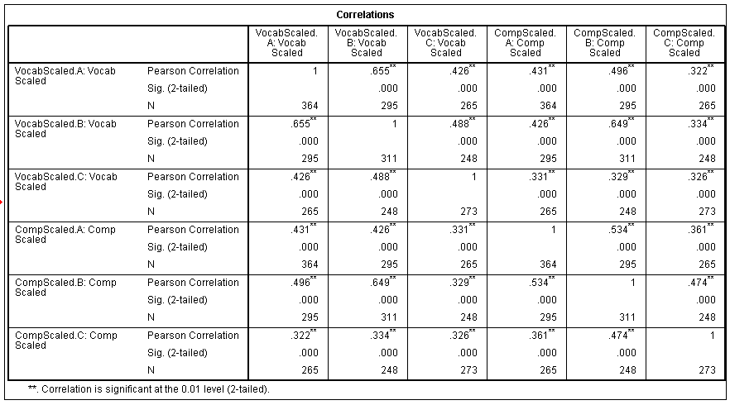
3c) There is a moderate positive relationship between Vocab. Tests A, B and C and Comprehension Tests A, B, and C as well because the Pearson correlation falls in the range of .35 and .65.

4a.) A Paired Samples T-Test was used because the differences of each paired variable was examined.
4b.)
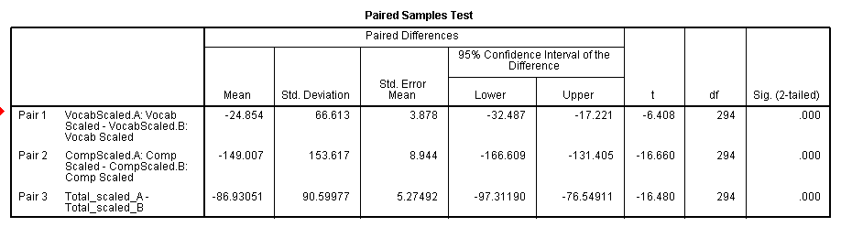
4c) A significant difference was seen between Test A and B for Vocab., Comp., and Total Scaled since the 2-tailed sig. is 0

5a.) Independent Samples Test was used because the “Cohort” is a grouping variable.
5b.)
Group Statistics
 | Cohort | N | Mean | Std. Deviation | Std. Error Mean
Total_scaled_A | Fall | 179 | 748.7291 | 99.53986 | 7.43996
Total_scaled_A | Spring | 185 | 757.3568 | 88.76985 | 6.52649
Total_scaled_B | Fall | 142 | 849.6937 | 117.08798 | 9.82581
Total_scaled_B | Spring | 169 | 825.4320 | 121.67500 | 9.35962
Total_scale_C | Fall | 136 | 848.9265 | 82.08475 | 7.03871
Total_scale_C | Spring | 137 | 843.3394 | 89.84852 | 7.67628

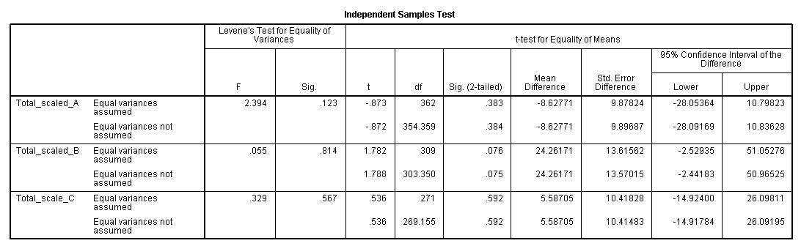

5c.) Examination of each Mean for Total Group Statistics for Fall and Spring there is an insignificant difference. When looking at the Sig. 2-tailed numbers, they are all above .05 therefore it is insignificant.

6a.) I used a correlation bivariate test for this question since I had to look at the nature of the relationship between more than 2 variables.
6b.)
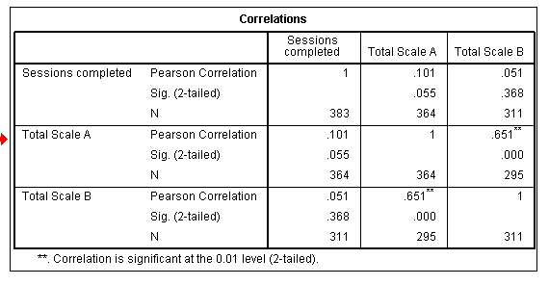
C) There is no significant relationships between any of the variables except for between Total Scale A and Total Scale B. There is a weak relationship between sessions completed and Total Scale A and sessions completed and Total Scale B because both numbers are below 0.35.

7a.) I performed two one-way ANOVAs because we needed to test verbal, comprehension and total of test B against both site and grade. After finding significance in the grade table I ran a Post-Hoc Scheffe test.
7b.)Grade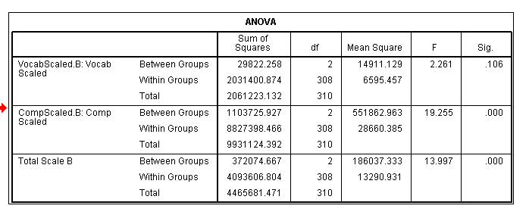
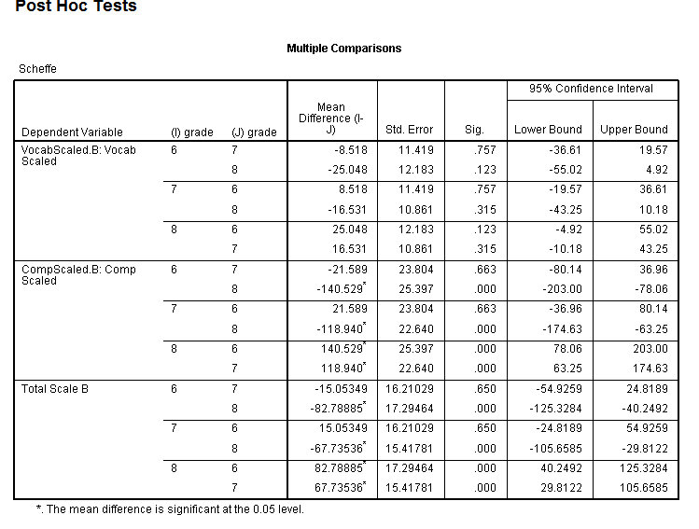
C) The tables show that by grade there was a significant difference between comprehension and total score. Also that by site there was significance with the vocabulary variable.
8.) Self- assessment: I worked with Dariah Juma, however I had to leave before we finished (we completed the process for #6 together.) She is a wonderful problem solver, collaborator and communicator. We seemed to mainly reason out the solution together, though I felt much slower to understanding than others around us. We were fairly well-matched. The only time we became stuck, Dariah confirmed with you whether we were on the right track and we were for #6.

